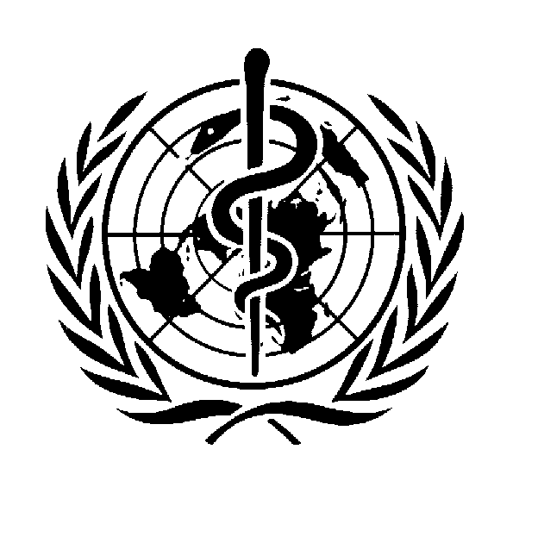 WORLD HEALTH ORGANIZATION

Terms of Reference
for
Health Systems Services (HSS)/Primary Health Care (PHC) Coordinator

Type of contract: Special Services Agreement (SSA)
Location: Mafraq, JORDAN
Level: NO-B
Duration: Until 31 December 2013, subject to renewal, according to availability . of funds

Objectives of the programme:
To ensure that effective WHO country presence is established to implement WHO country cooperation strategies that are aligned with Member State’s health and development agendas, and harmonized with the United Nations country teams.

The objectives of WHO's emergency humanitarian action (EHA) program in Jordan are as follows:

promptly assessing health needs of populations affected by crisis, identifying priority causes of ill-health and death; preparing damage estimates and emergency response and rehabilitation plans; providing prompt, credible health information and ensuring the continuity of essential health services;

- coordinating and monitoring emergency health relief efforts under the aegis of the Inter-Agency Standing Committee Health Cluster, of which WHO is the lead agency;

- ensuring that critical gaps in the health response are rapidly identified and filled;

- revitalizing and building the capacity of national health systems to deal with preparedness, mitigation and response.

Purpose of the function:
The WHO health assistance program in Jordan aims at the prevention of excessive morbidities and mortalities among displaced populations in Jordan and among the host communities through supporting and strengthening the MoH and other members of the health sectors and through coordinating program activities with international UN and non-UN partners.

Duties & Responsibilities:
Under the Supervision of the WR, the SSA holder shall perform the following duties:
- Supervise activities of the Field Office and ensure program and work plan implementation; lead, supervise and monitor a team of 4-5 contractors; ensure compliance with applicable administrative rules and procedures, draft financial reports relevant to the program activities.
- Perform, follow up and report on assessments relevant to the health of the displaced populations in the duty station. Collect, analyze and report on relevant data. Visit the communities and sites where displaced population are residing and report on the findings relevant to health.
- Organize and attend meetings with national and international partners and stakeholders on issues relevant to the program, including field meetings; report on the outcomes of these meetings.
- Performs Technical reviews of program plans, reports, proposals and other documents relevant to the program.
- Build local national capacity in the area of health systems by organizing and conducting training activities.
- Perform daily surveillance of the national, regional and international media sources to alert the organization to significant and urgent developments relevant to the target population. This includes the utilization of the relevant web-portals of sister agencies and humanitarian actors.
- Any other tasks / duties as needed by the WR.

Competencies:
- Producing Results

- Communicating in a credible and effective way

- Adopting integration and team work.

Required Skills and Experience:
Education:
Essential: University degree in medicine or in public health and health systems
Experience:
Essential: At least 3 years of experience in the area of Public Health, with some supervisory experience.
Languages:
Excellent knowledge of English and Arabic.
Other Skills:
Computer knowledge, particularly Microsoft Word, Excel and internet applications.
________________________________
Interested candidates should send their CVs to emwrojor@who.int maximum by 9 November 2013. Only short-listed candidates will be contacted. Local residents are highly-desirable.

