**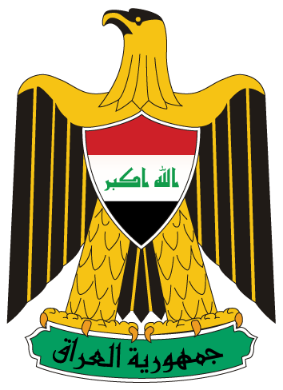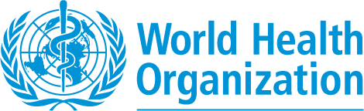***Press Release*

**WHO and Iraq Ministry of Health unite for a strong call to combat drug resistance**

## World Health Day 2011

## COMBAT DRUG RESISTANCE, NO action today, NO cure tomorrow.

**Baghdad, 10 April 2011** – “Save lives and protect health by keeping precious antimicrobial medicines effective to combat diseases” a joint call released today by the Ministry of Health and World Health Organization, as part of an awareness campaign to mark this year’s World Health Day.

Many of us live longer and healthier lives today, partly because of powerful and effective medicines known as antimicrobials that are available to treat infectious diseases. However the combination of overuse particularly for minor infections, misuse due to lack of access to appropriate treatment and under use due to lack of financial support to complete treatment courses are key drivers of drug resistance that may lead to avoidable deaths, greater suffering and disability, and unnecessary high health-care costs.

“Drug resistance has recently become a threat to global stability and national security in many countries and Iraq is no exception. Last year alone, there were 150 cases of multi drug resistant tuberculosis out of which five deaths were reported,” His Excellency Dr. Majeed Hamad Amin, Minister of Health of Iraq stated during the launch of World Health Day 2011 activities that took place this morning in Baghdad, in the presence of high level delegates representing the Iraqi Parliament, several ministries, UN agencies, civil society organizations and media. He further stressed that “none of us can imagine living in a world without antimicrobials and hence, urgent and consolidated efforts are needed to avoid regressing to the pre-antibiotic era.”

Dr Syed Jaffar Hussein, WHO Representative to Iraq stated: “Improving antimicrobial use must be a key action to contain resistance; this requires improving access and changing behaviors”. He further added that “Everyone who uses, prescribes or administers antibiotics and other antimicrobial agents has a role to play in this important work of preserving their efficacy for future generations. Action taken today means ensuring a cure for tomorrow”.

On this occasion of World Health Day 2011, WHO is issuing an international call for concerted action to halt the spread of antimicrobial resistance. In this respect, WHO is recommending a six-point policy package which include: (1) developing and implementing a comprehensive, financed national plan; (2) strengthen surveillance and laboratory capacity; (3) ensuring uninterrupted access to essential medicines of assured quality; (4) regulating and promoting rational use of medicines; (5) enhancing infection prevention and control; and (6) fostering innovation and research and development for new tools.

The Ministry of Health, with the support of the World Health Organization Iraq Country Office, is organizing an extensive media and awareness campaign in all governorates in Iraq where educational materials will be distributed in addition to organizing lectures, exhibitions and events for teachers, academia, doctors and pharmacists in primary health care centers and academic institutions.

Dr. Hussain re-affirmed the continuous commitment of WHO to support the Government of Iraq in combating drug resistance and warned that if this growing public health threat continues unchecked, many infectious diseases risk becoming uncontrollable and could derail progress made towards reaching the health-related Millennium Development Goals by 2015.

**For more information, please contact:**

**Ms. Ruba Hikmat, Media and Communication Officer, Tel. +96279-5096066,** [**hikmatr@irq.emro.who.int**](mailto:hikmatr@irq.emro.who.int) and **Ezechiel Bisalinkumi (Ph. D, MPH) Technical Officer, Essential Health Technologies and Pharmaceuticals (EHTP), Tel: +962 795053669**, [bisalinkumie@irq.emro.who.int](mailto:bisalinkumie@irq.emro.who.int)