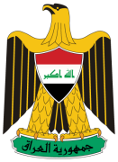
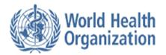

Press Release

Training workshop for central and local supervisors on congenital birth defects survey, Iraq

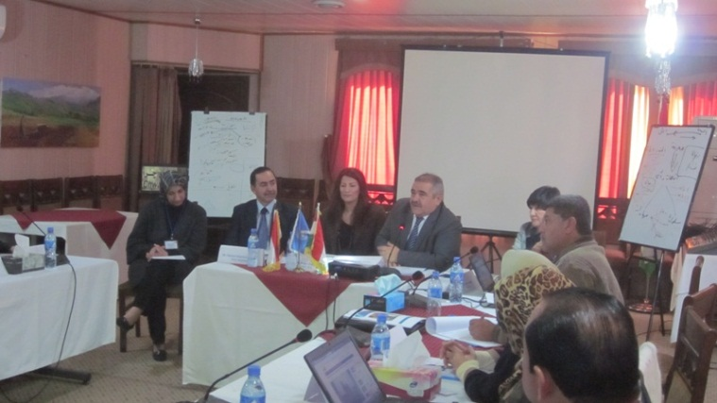
Erbil, 29 February 2012 – Under the patronage of H.E Dr Taher Hawrami, the Minister of Health of the Kurdistan Regional Government, the Federal and Kurdistan Ministries of Health of Iraq, in collaboration with WHO, are conducting a four-day training of trainers’ workshop from 27 February to 1 March 2012, in Erbil. Central and local supervisors are being trained as trainers on the congenital birth defects survey to be conducted in eight selected governorates in Iraq.
Figure 1H.E Dr Taher Hawrami, Minister of Health of the Kurdistan Regional Government, addressing participants of congenital birth defects survey workshop
During opening remarks, H.E Dr Hawrami stated, “There is a need for a comprehensive programme to learn more about birth defects in Iraq that could shed light on the incidence of various conditions, such as congenital heart defects and neurological defects, in different geographic areas over time in Iraq.”
Concern continues over the increased number of congenital birth defects in the country, however, there is no scientifically-reliable data on the magnitude of birth defects and associated risk factors in Iraq.
Priority will be given in the survey to measuring the magnitude and trend of congenital birth defects at selected district level, identifying possible risk factors of congenital birth defects and assessing the burden of these conditions and impact on the health status of care providers.
The workshop is being attended by 25 health professionals from Baghdad, Erbil, Suleimainya, Basra, Anbar, Diyala, Babel, Mosul and Thi-Qar. Participants will be trained on data collection tools, including questionnaires and instruction manuals, survey methodology and the field work implementation plan, with roles and responsibilities clearly identified.
It is expected that the survey will be conducted in April 2012. Protocol and tools have already been revised and finalized through three successive meetings of the members of the steering committee from the Federal and Kurdistan Ministries of Health, the Ministry of Planning and civil society organizations, in coordination with WHO technical experts and consultants.

For more information:
Dr. Faiza Majeed, National Professional Officer, majeedf@irq.emro.who.int , +96279-5017767

