
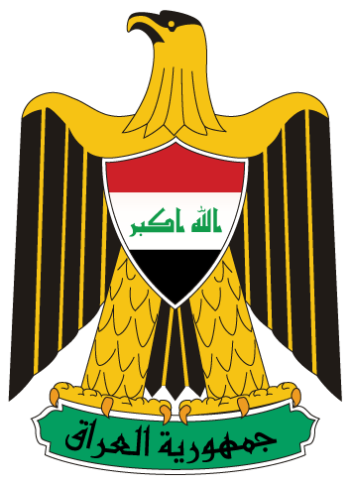

Country Cooperation Strategy Meeting in Amman

Amman, 20 December 2011 – The Ministry of Health, in collaboration with the World Health Organization (WHO), completed a three-day workshop to present the results of the Country Cooperation Strategy (CCS) for the year 2012-2017. The (CCS) is a medium-term strategic framework that defines (WHO)'s strategic agenda in Iraq. The (CCS) built on the UNDAF, the new National development Plan (NDP) and the Joint Programme Review Mission (JPRM).

Under this strategy, a three-day workshop to analyze and introduce the principles of CCS-Iraq took place in Amman between 18-20 December 2011 with the presence of H.E the Minister of Health Dr. Majeed Hamad Amin, Member of Parliament-Chairperson of Health and Environment Committee in the Iraqi Parliament, Dr. Liqaa Al- Yassin, Senior Deputy Minister of Health for Reconstruction and Donors Affairs, Dr. Essam Namiq, and Head of Health and Environment Committee at the Kurdistan Paliament, Dr. Hasan Sora, along with 21 delegations from the Ministry of Health, Ministry of Planning, Ministry of Education, World Health Organization regional consultants and WHO’s experts.

The CCS reflected the medium-term vision for technical cooperation with a given country and defined a strategic framework for working in and with the country. The CCS process reflected global and regional health priorities with the aim of bringing together the strength of WHO support at country, regional offices and Headquarters level in a coherent manner to address the country’s health priorities and challenges.

During the meeting, the participants worked together to validate the data, verify major activities under each program and identify gaps, needs and priorities. The overall purpose was to provide a foundation and strategic basis for planning as well as to improve WHO’s contribution to the Member States for achieving the Millennium Development Goals (MDGs).

H.E Dr. Majeed Hamad Amin emphasized that the CCS examined the health situation in the country with a holistic approach that encompasses the health sector, socioeconomic status, the determinants of health and upstream national policies and strategies that have a major bearing on health.

Member of Parliament-Chairperson of Health and Environment Committee in the Iraqi Parliament, Dr. Liqaa Al Yassin stressed on the importance of the strategy in improving health services system and updating the old foundations to a new one.

Dr. Syed Jaffer Hussain, Representative and Head of Mission of WHO Iraq stated that the data being reviewed provided information on the core features and the use of the CCS. He also stressed that WHO country teams should support such evolutions which will contribute to a better articulation of the UNDAF along with MDGs’s line-ministries and SWAPs, taking into account country specificities, and WHO’s participation in the quality assurance support mechanisms set by the UNDG at regional level should also help in taking forward the orientations proposed above.

At the end of the workshop, the participants agreed on the needs to revise and update the Country Cooperation Strategy, in addition to provide a periodical review with the all concerned partners and the relevant ministries.

For more information, please contact:
Dr. Omer Mekki, WHO Medical Officer, mekkio@irq.emro.who.int
and WHO Iraq Country Office, wiraq@irq.emro.who.int

