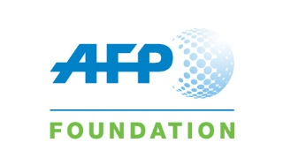

MAINSTREAMING HEALTH PROMOTION IN MEDIA TRAINING programme
APPLICATION FORM

Full name
Date of birth
Country/nationality
Name and address of media affiliation
Type of media (print, TV or radio) | Indicate the type of media of interest
Number of years of experience as a media professional
Have you taken part in any media training before? (if yes, please specify)
How did you learn about the training?

Please write briefly about your expectations from the training.

THANK YOU

