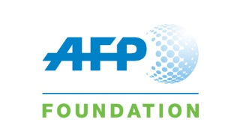
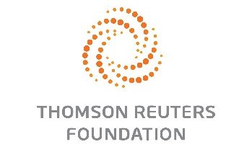
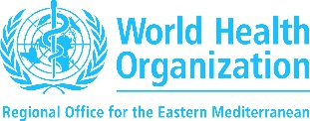

MAINSTREAMING HEALTH PROMOTION IN the MEDIA TRAINING programme

“I ____________________________________ understand that I have been nominated to attend a course on “Mainstreaming health promotion in the media” organized by the World Health Organization, Thomson Reuters Foundation, Agence France Presse Foundation and other regional organizations.

I agree to attend and fully participate in the training and I also agree to fully participate in the 3-month remote mentoring period under the guidance of an expert. I understand that I am required to complete a certain number of assignments at an acceptable level during this mentoring period.

Once I have completed the assignments to a satisfactory level, I will be eligible to graduate and receive my certification for completing the training programme.”

