HIV surveillance electronic reporting system
User manual

December 2014

Welcome to the HIV surveillance reporting system of the WHO Regional Office for the Eastern Mediterranean. This manual will guide you through the process. The system can be used with any browser, although we recommend using Mozilla Firefox or Google Chrome browsers for DHIS 2. Data entry is also possible with Microsoft Internet Explorer, but there can be problems in displaying totals in data entry fields.

Overview of the system

Logging in
The system is accessed through http://rho.emro.who.int/dhis/
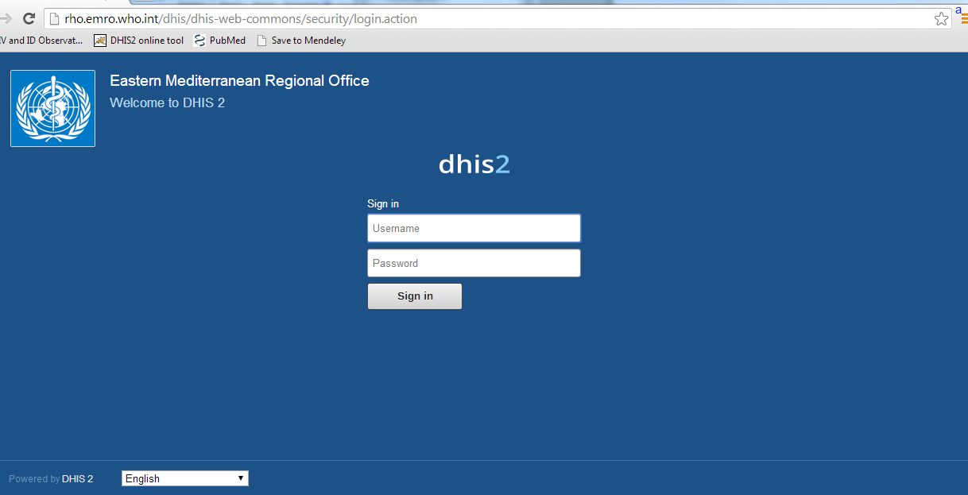
Enter the provided username and password. Pressing “enter” on the keyboard or the “Sign in” button brings you to the DHIS2 main page called the dashboard.
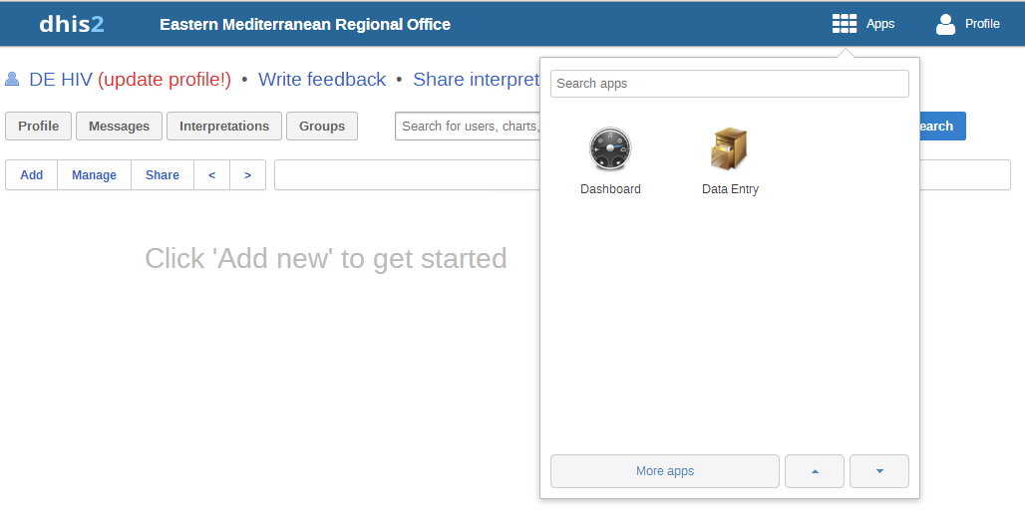
In the top right corner there are two icons, “Apps” and “Profile”. Bringing the mouse over the Apps icon opens a box containing “Dashboard” and “Data Entry” icons. “Data Entry” is used for reporting and is described in detail below.
Clicking on the Dashboard icon brings you to this home screen (see below). This view can later contain reports of the data that you entered.
Profile lets you access Settings, add information to your profile and access Help files. The Account function can be used to change passwords. Logging out of the system is also done from here.
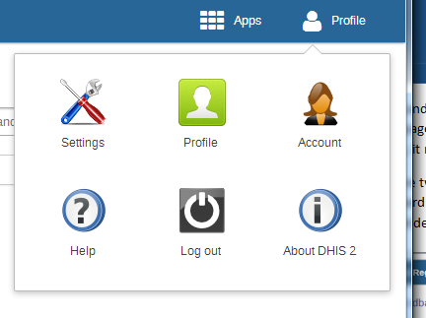

Entering data
To enter data, click on data entry. This will open a page with a box with three fields:
- Organisation unit: corresponds to the country you are reporting from;
- Data set: refers to the different items that can be reported; and
- Period: this is the reporting year.
Please check that the administrative unit (country) is correct and choose the data set and year that you are reporting on. All three fields must be selected in order to access the data entry form.
Underneath every form there are three buttons:
- Incomplete: Data can be marked as incomplete if it will not be entered all at once.
- Complete: Click complete, once the data set is done
- Run validation: This function checks the data against predefined rules (such as all numbers must be positive without decimals).
On the right there are three buttons:
- Run validation: Run validation has the same function as the button underneath the data entry form.
- Print form: allows you to print the data entry forms with your entered data.
- Print blank form: allows you to print a blank data entry form.

The data sets

HIV cases

HIV cases by age and sex
Please fill in numbers of HIV cases by age and sex. There are two parts to the initial table, for the current reporting year and the cumulative total.
The tables calculate totals by row and column. Age groups are 0–4, 5–14, 15–24 and 25+. There is the possibility to add unknown on both sex and age. The age disaggregation is different from the reporting in 2013, and there is now a 0–4 years age group bracket to better reflect treatment guidelines. If you cannot provide the numbers for the same age groups, use unknown age groups.
Below the first table, there is a similar table for the age group 0–15, for all paediatric cases.

HIV cases by mode of transmission
This table has disaggregation by sex. Please use unknown for modes of transmission that do not fit elsewhere. The total number of HIV cases should match.

CD4
There are two fields to report in this table. The first one is the number of newly diagnosed HIV cases, who have had an initial CD4 cell count done and reported.
Based on this, the table automatically calculates the proportion of reported cases that have had this examination.
The second reported number is the number of these cases with an initial CD4 count < 200. This corresponds with the threshold of antiretroviral treatment (ART) initiation in other guidelines: the number of people living with HIV (PLHIV) initiating ART within the past 12 months with a baseline CD4 count of < 200 cell/mm3.
The form automatically calculates the percentage of PLHIV below this threshold.

AIDS death cases by age and sex
This table is for reporting AIDS-related deaths with a disaggregation for sex and age. The age groups are 0–14 and 15+. There is the possibility to enter numbers under unknown groups for both sex and age, and the totals are calculated automatically.

HIV testing
This form is for reporting HIV testing data. The number of tests and number found to be positive are reported, and the positive percentage is calculated automatically. The testing data is disaggregated into groups corresponding with different testing scenarios covering outreach activities with risk groups, and different routine testing settings. There are three groups of “other” for which a clarification should be presented. Totals are calculated automatically.

HIV special surveys
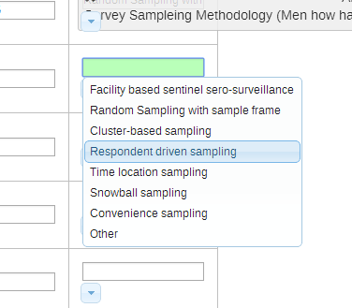
This section covers surveillance activities among defined populations. For each study, please report the number of HIV positive cases found and the total sample size. The prevalence is calculated automatically. For survey methodology, clicking on the small downward arrow opens a list of alternatives such as in the picture below. If the survey was done by a methodology that does not fit any of the alternatives offered, please choose convenience sample.

The populations are sexually transmitted infection (STI) patients, TB patients, antenatal clinic (ANC) attendees, sex workers, men who have sex with men (MSM), people who inject drugs (PWID), prisoners, and three “other” groups with the possibility to enter a definition.

Advanced surveillance
This section is currently used for two kinds of HIV surveillance activities: modes of transmission analysis; and population size estimations of key populations.

Modes of transmission analysis
The modes of transmission analysis refers to a standardized exercise to calculate expected transmission patterns of HIV based on current information on prevalence and behaviour.
Guidance on mode of transmission analysis can be found in http://www.unaids.org/en/dataanalysis/datatools/incidencebymodesoftransmission/
The required data is a percentage of new infections by mode of transmission.

Population size estimates
Population size estimates are needed to estimate epidemiological patterns, especially in concentrated epidemic settings.
If recent population size estimations have been done in your country, please enter the relevant data. The needed inputs are: number of members of key population, is the estimate national or subnational, what was the method used and when was the exercise done. Please use the most relevant and latest estimation, and provide national estimates where available. The data can be entered for sex workers, PWID, MSM and prisoners. If a population size estimation exercise has been contacted in another key group, this can be presented as “other”.

STI cases

Number of STI cases (etiological laboratory diagnosis) by sex and age group
This form is for laboratory-confirmed diagnoses on all STIs disaggregated by sex and age. The diagnostic groups are the following:
- syphilis
- chancroid
- herpes simplex type 2 (hsv-2)
- gonorrhoea
- chlamyidia
- trichomoniasis
- all other STIs.

STI cases diagnosis by syndrome
The syndromic STI reporting includes reports of urethral discharge for men and genital ulcers for both men and women. Most countries only collect some of this information. Please report any available data on the relevant forms.

Hepatitis cases
This is a case reporting platform for hepatitis B and hepatitis C. Please fill in the number tested and number positive as with the HIV cases form. The aggregation is by the following groups:
- blood donors
- pregnant women
- STI patients
- PWID
- others.
Similarly to HIV case reporting, there are two tables each for hepatitis B and C. The first one is for cases registered in the reporting year and the second is for the cumulative total.
For more information or for help: Please contact emrgohas@who.int

