**Initial country report on progress towards measles and rubella elimination**

**[Name of country]**

**YEAR ….**

Submitted by:

Chair of National Verification Committee

Signature:

Name:

Date:

Purpose of the report

The purpose of this report is to provide convincing and well-structured evidence to demonstrate that a country has met the verification criteria for measles and rubella elimination and the country is able to sustain its achievements. Countries must provide evidence that they have interrupted endemic measles and rubella virus transmission for a period of at least 36 months under conditions of verification standard surveillance.

The following template provides guidance to countries to provide verification documents to the Regional Verification Committee (RVC) through the National Verification Committee (NVC). Countries are encouraged to analyse and present data in whatever format they feel is most appropriate to fully describe and communicate the status of measles and rubella elimination along the lines of evidence of measles/rubella elimination.

Executive summary

**Conclusion of the National Verification Committee on measles and rubella elimination status in** (country name) **in** (year ….):

***Instructions:*** *Please provide your statement on the status of measles and rubella virus circulation in your country, based on the information provided by the national surveillance and immunization systems. Tick the boxes below as deemed appropriate and provide summary along the lines of evidence (main facts that led to the NVC’s conclusion). If you have difficulties in selecting one of the three status definitions for measles and rubella elimination, please leave the boxes unchecked and explain in the text box. Please delete provided text and enter your text addressing mentioned areas in the below box.*

**Measles:**

Endemic

Interrupted endemic transmission for……….……months

Re-established endemic transmission for…………months

The NVC conclusion is based on the following:

|  |
| --- |
| **Epidemiology of measles:** number and description of cases and outbreaks (person-time-place, seasonality, immunization status, known origin, adequate confirmation and discarding of cases).  **Molecular epidemiology of measles:** comprehensive analysis of epidemiological and laboratory data on detected genotypes/lineages of measles viruses, and extended to analysis of available data from previous and following year looking for/to exclude continuous circulation of >12 months.  **Measles surveillance quality:** systems quality and capacity to detect, report, investigate and confirm/discard suspected cases all over the country for the entire year; performance against surveillance indicators and other reliable indicators used in country to confirm adequate surveillance quality and performance; additional activities (active case finding, retrospective case/data analysis, addressing “silent” territories and populations); integration with laboratory segment of surveillance for confirming cases and genotypes/lineages (sporadic cases and outbreaks); and strengths and weaknesses of surveillance data quality.  **Activities to achieve and maintain high population immunity:** routine immunization programme coverage at national and subnational levels, and especially where suboptimal programme performance exists (for example, age cohorts, territories and/or specific population with known low coverage); supplemental immunization activities and coverage; additional studies and surveys about immunity to MR; and strengths and weaknesses of immunization data quality.  **Sustainability of and commitment to activities on measles/rubella elimination:**political commitment; decision-making structures and main players; involvement of partners; promotion of and advocacy for elimination; sustainability of immunization programme; political and technical regulation and guidelines developed or renewed; secure fundsand vaccine supply; organized activities towards particular groups (for example, health care workers – to increase knowledge, population; to increase demand). |

**Rubella and congenital rubella syndrome (CRS)**

Endemic

Interrupted endemic transmission for …………… months

Re-established endemic transmission for ………… months

The NVC conclusion is based on the following:

|  |
| --- |
| **Epidemiology of rubella and CRS:** number and description of cases and outbreaks (person-time-place, seasonality, immunization status, known origin, adequate confirmation and discarding of cases).  **Molecular epidemiology of rubella:** comprehensive analysis of epidemiological and laboratory data on detected genotypes/lineages of rubella viruses, and extended to analysis of available data from previous and following year looking for/to exclude continuous circulation of >12 months.  **Rubella** **and** **CRS** **surveillance quality:** systems quality and capacity to detect, report, investigate and confirm/discard suspected cases all over the country for the entire year; performance against surveillance indicators, other reliable indicators used in country to confirm adequate surveillance quality and performance; additional activities (active case finding, retrospective case/data analysis, addressing “silent” territories and populations); integration with laboratory segment of surveillance for confirming cases and genotypes/lineages (sporadic cases and outbreaks); and strengths and weaknesses of surveillance data quality.  **Activities** **to** **achieve** **and** **maintain** **high** **population** **immunity:** routine immunization programme coverage at national and subnational levels, and especially where suboptimal programme performance exists (for example, age cohorts, territories and/or specific population with known low coverage); supplemental immunization activities and coverage; additional studies and surveys about immunity to MR; and strengths and weaknesses of immunization data quality.  **Sustainability** **of** **and** **commitment** **to** **activities** **on** **MR** **elimination:** political commitment, decision-making structures and main players, involvement of partners, promotion of and advocacy for elimination, sustainability of immunization programme, political and technical regulation and guidelines developed or renewed, secure funds and vaccine supply, organized activities towards particular groups (for example, health care workers – to increase knowledge, population; to increase demand). |

Section 1. The National Verification Committee (NVC)

***Instructions:*** *Please* *provide below the following information about the NVC:*

* *History of establishment and meeting of the NVC.*
* *List of members of the NVC.*
* *Secretariat support to NVC: Please describe secretariat support, composition, functions, activities implemented, available resources, challenges* *and other support.*
* *NVC activities in (provide year): Please provide a brief summary of the NVC activities in the year under review and current year to date, including key issues addressed from the meetings, and list any concerns that have arisen, including concerns from the NVC about the national programme, and challenges in organizing and/or holding regular NVC meetings.*
* *NVC workplan for the next year.*
* *Other activities, as applicable, such as attendance of RVC meetings, feedback to NIP for action on RVC recommendations, or field visits when required, particularly for advocacy purposes. Please provide the NVC (and national technical counterparts’) response to RVC’s comments/conclusion and recommendation, summarizing the conducted interventions and activities.*

Date of establishment:

Date of reorganization:

Date of first meeting:

Is it a standalone committee or does it also have other verification/certification functions?

Yes No

If the NVC has other verification/certification functions, please describe them:

1. **Members of the National Verification Committee**

*(Please notify any changes.)*

|  |  |  |  |  |  |  |
| --- | --- | --- | --- | --- | --- | --- |
|  | **Name** | **NVC status (chair/member)** | **Area of expertise** | **Occupation/position/ affiliation** | **Contact details (email; tel.)** | **Signature** |
| 1 |  |  |  |  |  |  |
| 2 |  |  |  |  |  |  |
| 3 |  |  |  |  |  |  |
| 4 |  |  |  |  |  |  |
| 5 |  |  |  |  |  |  |
| 6 |  |  |  |  |  |  |
| 7 |  |  |  |  |  |  |
| 8 |  |  |  |  |  |  |
| 9 |  |  |  |  |  |  |
| 10 |  |  |  |  |  |  |
| 11 |  |  |  |  |  |  |
| 12 |  |  |  |  |  |  |

1. **Secretariat support to NVC**
2. **General information on the activities of the NVC in 2019**

*(Please insert extra rows as needed.)*

|  |  |  |  |
| --- | --- | --- | --- |
|  | **Date** | **Activity** | **Highlights and challenges** |
| 1 |  |  |  |
| 2 |  |  |  |
| 3 |  |  |  |

1. **NVC plan for the next year**

*(Please insert extra rows as needed.)*

|  |  |  |  |
| --- | --- | --- | --- |
|  | **Activity** | **Timeline** | **Expected outcomes** |
| 1 |  |  |  |
| 2 |  |  |  |
| 3 |  |  |  |

1. **NVC response to comments, conclusion and recommendations of RVC on the previous report**

|  |
| --- |
|  |

1. **Other activities of the NVC as applicable**

*(For example, activities such as attendance at RVC meetings, field visits.)*

Section 2. Country background information and programme history

***Instructions:*** *Information on the country situation, including demography as well as programme history, will assist giving context to the data presented to the RVC for verification. These data will be generated for the initial country report, and will only be required to be updated annually for the annual progress report.*

**2.1 Country background**

1. Geographic description:
2. Demography and population characteristics:
3. *Demography on the national level for the year of the report:*

|  |  |  |
| --- | --- | --- |
| *Population density:* |  | |
| *Population size:* |  | |
| *Population growth rate:* |  | |
| *Under-1 population:* |  | |
| *Under-5 population:* |  | |
| *Under-15 population:* |  | |
| *Women of reproductive age:* |  | |
| *Infant mortality rate:* |  | |
| *Under-5 mortality rate:* |  | |
| *Urban population:* |  | |
| *Rural population:* |  | |
| *Migrant/expatriate population:* | |  |

1. *Demography on the subnational level for the year of the report:*

|  |  |  |
| --- | --- | --- |
| *Population density:* |  | |
| *Population size:* |  | |
| *Population growth rate:* |  | |
| *Under-1 population:* |  | |
| *Under-5 population:* |  | |
| *Under-15 population:* |  | |
| *Women of reproductive age:* |  | |
| *Infant mortality rate:* |  | |
| *Under-5 mortality rate:* |  | |
| *Urban population:* |  | |
| *Rural population:* |  | |
| *Migrant/expatriate population:* | |  | |

1. Description of high-risk populations for measles/rubella infection and reasons for their high level of risk  *(e.g. migrant workers, populations living in insecure areas, generally underserved populations, individuals served by private providers, urban slums, mass gatherings, borders with endemic countries, etc.)*:
2. Description of the health care delivery system and EPI service providers of the country:
   1. **Description of the NIP components**
3. National targets and goals:

1. Structure of the immunization programme:

1. EPI supporting bodies (e.g. Interagency Coordinating Committee, NITAG, etc.):

1. The country’s human resource capacities for MR surveillance and laboratory capacity:
2. The national MR plan of action:

**2.3 History of the measles and rubella control/elimination programme in the country**

1. Description of national elimination goals and targets[1]
2. Description of the history of the vaccination schedule for measles and rubella:

*(Current and historic immunization schedule for MCV and RCV and number of doses (if any), including vaccination of adolescent and adult females, school entry and prenatal screening.)*

|  |  |  |  |  |
| --- | --- | --- | --- | --- |
| **Year of introduction** | **Type of vaccine (M, MR, MMR, MMRV) and doses (MCV1, MCV2, RCV1, RCV2)** | **Schedule (age by month)** | **School entry requirements for measles (Yes, No)** | **Prenatal screening**  **(Yes, No)** |
|  |  |  |  |  |
|  |  |  |  |  |
|  |  |  |  |  |
|  |  |  |  |  |
|  |  |  |  |  |

1. Description of evolution of strategies for controlling and eliminating measles and rubella:

1. Description of relevant surveillance systems and establishment of case-based measles and rubella surveillance including standard case definitions:
2. Description of the structure and function of CRS surveillance in the country:
3. Information on any special studies (for example, identifying CRS cases through review of rubella in pregnancy registries or retrospective medical record searches for CRS cases):
4. Surveillance guidelines and other related documents may be attached, for example, as an annex:

Section 3. Lines of evidence

1. **First line of evidence: epidemiology of measles and rubella**

*Description of the progress towards measles elimination in the country starting from the time of vaccine introduction should be provided. The narrative should correlate changes in incidence with immunization interventions undertaken at any specific year for example, routine immunization coverage, catch-up or follow-up SIAs which can be illustrated by graphs, maps and/or tables.*

***Instructions:*** *Please provide the following information*:

* *Number of cases, total incidence, incidence of indigenous cases of measles, rubella and CRS at the national and genotype of measles and rubella prior to measles and rubella vaccine introduction. If not available, provide data for the last the last ten years.*
* *Number and incidence of confirmed cases at subnational level (province and district) illustrated in table, map showing incidence by district in the last 5 years.*
* *Final classification of cases according to confirmation (laboratory-confirmed, epidemiologically linked, clinically compatible, and discarded), source of infection status (imported, import-related, unknown source, endemic) and genotyping.*
* *Monthly epidemic curve of measles/rubella cases.*
* *Distribution of cases by age cohort, vaccination status.*
* *Cohort analysis showing the correlation between age of measles cases in 2019, the national coverage at the time they were expected to be vaccinated, the year of the SIA with SIA survey coverage and the routine immunization coverage for MCV1 and MCV2. (Please see verification guide Figure 3.)*
* *Review of any special cases, for example, equivocal, indeterminate cases, vaccine-associated cases.*
* *Detailed description of the characteristics of clinically compatible cases, illustrated by map to show location and clustering, if present. Information on age and immunization status and clinical signs and symptoms consistent with measles (yes or no) and cases discarded by the Expert Review Committee.*
* *Measles and rubella outbreaks:*
  + - *Each outbreak or chain of transmission should report only one genotype. If more than one genotype is reported for an outbreak, this refers to more than one chain of transmission and should be described as a separate outbreak in the table. Please include an additional descriptive paragraph in each outbreak including the setting, the identified immunity gap and measures taken to eliminate this gap in similar populations to prevent future outbreaks. Maps of cases or epidemic curves maybe included. All outbreak investigation reports for last 5 years should be attached as an annex.*
    - *Temporal and spatial association: temporal patterns through incidence graphs demonstrate trends. Spatial patterns can indicate areas where measles interruption may have been achieved, as well as noting whether confirmed cases occur in isolation or in possible transmission chains and identifying epidemiologically linked cases. Special attention should be given to unknown source cases, including if they fit a geospatial pattern that might suggest endemic transmission. Age distribution and vaccination status (by year of birth) should be presented in tables and bar charts to illustrate progress towards elimination.*
* *CRS:*

*Information on CRS cases and epidemiology should include the following:*

* *number of CRS cases over the time period of evaluation*
* *annual incidence per 10 000 live births if available*
* *final classification and importation status of cases.*
  + 1. **Measles**

1. Measles cases, incidence and genotype at the national level since the introduction of the MCV: *

|  |  |  |  |  |  |  |  |  |  |  |  |
| --- | --- | --- | --- | --- | --- | --- | --- | --- | --- | --- | --- |
| **Measles** |  |  |  |  |  |  |  |  |  |  |  |
| **Total suspected cases** |  |  |  |  |  |  |  |  |  |  |  |
| **Total confirmed cases** |  |  |  |  |  |  |  |  |  |  |  |
| **Total discarded** |  |  |  |  |  |  |  |  |  |  |  |
| **Pending classification** |  |  |  |  |  |  |  |  |  |  |  |
| **Total deaths related to measles** |  |  |  |  |  |  |  |  |  |  |  |
| **Total incidence of cases** |  |  |  |  |  |  |  |  |  |  |  |
| **Incidence of indigenous cases** |  |  |  |  |  |  |  |  |  |  |  |
| **Genotype(s)** |  |  |  |  |  |  |  |  |  |  |  |

*\*(Please add columns as needed.)*

1. Measles cases and incidence at subnational level (province and districts as applicable):

**2019**

|  |  |  |  |  |  |  |  |  |  |  |  |  |  |  |  |  |
| --- | --- | --- | --- | --- | --- | --- | --- | --- | --- | --- | --- | --- | --- | --- | --- | --- |
| **Province** | **District** | **Population size** | **Jan** | **Feb** | **Mar** | **Apr** | **May** | **Jun** | **Jul** | **Aug** | **Sep** | **Oct** | **Nov** | **Dec** | **Total** | **Incidence rate** |
|  |  |  |  |  |  |  |  |  |  |  |  |  |  |  |  |  |
|  |  |  |  |  |  |  |  |  |  |  |  |  |  |  |  |  |
|  |  |  |  |  |  |  |  |  |  |  |  |  |  |  |  |  |
|  |  |  |  |  |  |  |  |  |  |  |  |  |  |  |  |  |
|  |  |  |  |  |  |  |  |  |  |  |  |  |  |  |  |  |
|  |  |  |  |  |  |  |  |  |  |  |  |  |  |  |  |  |
|  |  |  |  |  |  |  |  |  |  |  |  |  |  |  |  |  |
|  |  |  |  |  |  |  |  |  |  |  |  |  |  |  |  |  |
|  |  |  |  |  |  |  |  |  |  |  |  |  |  |  |  |  |
|  |  |  |  |  |  |  |  |  |  |  |  |  |  |  |  |  |

**2018**

|  |  |  |  |  |  |  |  |  |  |  |  |  |  |  |  |  |
| --- | --- | --- | --- | --- | --- | --- | --- | --- | --- | --- | --- | --- | --- | --- | --- | --- |
| **Province** | **District** | **Population size** | **Jan** | **Feb** | **Mar** | **Apr** | **May** | **Jun** | **Jul** | **Aug** | **Sep** | **Oct** | **Nov** | **Dec** | **Total** | **Incidence rate** |
|  |  |  |  |  |  |  |  |  |  |  |  |  |  |  |  |  |
|  |  |  |  |  |  |  |  |  |  |  |  |  |  |  |  |  |
|  |  |  |  |  |  |  |  |  |  |  |  |  |  |  |  |  |
|  |  |  |  |  |  |  |  |  |  |  |  |  |  |  |  |  |
|  |  |  |  |  |  |  |  |  |  |  |  |  |  |  |  |  |
|  |  |  |  |  |  |  |  |  |  |  |  |  |  |  |  |  |
|  |  |  |  |  |  |  |  |  |  |  |  |  |  |  |  |  |
|  |  |  |  |  |  |  |  |  |  |  |  |  |  |  |  |  |
|  |  |  |  |  |  |  |  |  |  |  |  |  |  |  |  |  |

**2017**

|  |  |  |  |  |  |  |  |  |  |  |  |  |  |  |  |  |
| --- | --- | --- | --- | --- | --- | --- | --- | --- | --- | --- | --- | --- | --- | --- | --- | --- |
| **Province** | **District** | **Population size** | **Jan** | **Feb** | **Mar** | **Apr** | **May** | **Jun** | **Jul** | **Aug** | **Sep** | **Oct** | **Nov** | **Dec** | **Total** | **Incidence rate** |
|  |  |  |  |  |  |  |  |  |  |  |  |  |  |  |  |  |
|  |  |  |  |  |  |  |  |  |  |  |  |  |  |  |  |  |
|  |  |  |  |  |  |  |  |  |  |  |  |  |  |  |  |  |
|  |  |  |  |  |  |  |  |  |  |  |  |  |  |  |  |  |
|  |  |  |  |  |  |  |  |  |  |  |  |  |  |  |  |  |
|  |  |  |  |  |  |  |  |  |  |  |  |  |  |  |  |  |
|  |  |  |  |  |  |  |  |  |  |  |  |  |  |  |  |  |
|  |  |  |  |  |  |  |  |  |  |  |  |  |  |  |  |  |
|  |  |  |  |  |  |  |  |  |  |  |  |  |  |  |  |  |

**2016**

|  |  |  |  |  |  |  |  |  |  |  |  |  |  |  |  |  |
| --- | --- | --- | --- | --- | --- | --- | --- | --- | --- | --- | --- | --- | --- | --- | --- | --- |
| **Province** | **District** | **Population size** | **Jan** | **Feb** | **Mar** | **Apr** | **May** | **Jun** | **Jul** | **Aug** | **Sep** | **Oct** | **Nov** | **Dec** | **Total** | **Incidence rate** |
|  |  |  |  |  |  |  |  |  |  |  |  |  |  |  |  |  |
|  |  |  |  |  |  |  |  |  |  |  |  |  |  |  |  |  |
|  |  |  |  |  |  |  |  |  |  |  |  |  |  |  |  |  |
|  |  |  |  |  |  |  |  |  |  |  |  |  |  |  |  |  |
|  |  |  |  |  |  |  |  |  |  |  |  |  |  |  |  |  |
|  |  |  |  |  |  |  |  |  |  |  |  |  |  |  |  |  |
|  |  |  |  |  |  |  |  |  |  |  |  |  |  |  |  |  |
|  |  |  |  |  |  |  |  |  |  |  |  |  |  |  |  |  |
|  |  |  |  |  |  |  |  |  |  |  |  |  |  |  |  |  |
|  |  |  |  |  |  |  |  |  |  |  |  |  |  |  |  |  |

**2015**

|  |  |  |  |  |  |  |  |  |  |  |  |  |  |  |  |  |
| --- | --- | --- | --- | --- | --- | --- | --- | --- | --- | --- | --- | --- | --- | --- | --- | --- |
| **Province** | **District** | **Population size** | **Jan** | **Feb** | **Mar** | **Apr** | **May** | **Jun** | **Jul** | **Aug** | **Sep** | **Oct** | **Nov** | **Dec** | **Total** | **Incidence rate** |
|  |  |  |  |  |  |  |  |  |  |  |  |  |  |  |  |  |
|  |  |  |  |  |  |  |  |  |  |  |  |  |  |  |  |  |
|  |  |  |  |  |  |  |  |  |  |  |  |  |  |  |  |  |
|  |  |  |  |  |  |  |  |  |  |  |  |  |  |  |  |  |
|  |  |  |  |  |  |  |  |  |  |  |  |  |  |  |  |  |
|  |  |  |  |  |  |  |  |  |  |  |  |  |  |  |  |  |

Spot maps to present geographical distribution of total measles cases by province/district for the last 5 years:

Colour code for spot map:

Green : Sporadic “imported” cases (unrelated to any other case in the country)

Yellow: Case is part of an outbreak (>1 case)

Red: Sporadic “unknown” case (unrelated to any other case in the country)

Spot maps to present geographical distribution of discarded measles cases by province/district for the last 5 years:

Colour code for spot map:

* Red: >2/100000
* Green: <2/1000000

1. Measles cases by final classification and source of infection at national level for the last 5 years:

**2019**

|  |  |  |  |  |
| --- | --- | --- | --- | --- |
| **Confirmation**  **Source of infection** | **Laboratory-confirmed** | **Epidemiologically linked** | **Clinically compatible** | **Total** |
| **Endemic** |  |  |  |  |
| **Unknown** |  |  |  |  |
| **Imported** |  |  |  |  |
| **Import-related** |  |  |  |  |
| **Total** |  |  |  |  |

**2018**

|  |  |  |  |  |
| --- | --- | --- | --- | --- |
| **Confirmation**  **Source of infection** | **Laboratory-confirmed** | **Epidemiologically linked** | **Clinically compatible** | **Total** |
| **Endemic** |  |  |  |  |
| **Unknown** |  |  |  |  |
| **Imported** |  |  |  |  |
| **Import-related** |  |  |  |  |
| **Total** |  |  |  |  |

**2017**

|  |  |  |  |  |
| --- | --- | --- | --- | --- |
| **Confirmation**  **Source of infection** | **Laboratory-confirmed** | **Epidemiologically linked** | **Clinically compatible** | **Total** |
| **Endemic** |  |  |  |  |
| **Unknown** |  |  |  |  |
| **Imported** |  |  |  |  |
| **Import-related** |  |  |  |  |
| **Total** |  |  |  |  |

**2016**

|  |  |  |  |  |
| --- | --- | --- | --- | --- |
| **Confirmation**  **Source of infection** | **Laboratory-confirmed** | **Epidemiologically linked** | **Clinically compatible** | **Total** |
| **Endemic** |  |  |  |  |
| **Unknown** |  |  |  |  |
| **Imported** |  |  |  |  |
| **Import-related** |  |  |  |  |
| **Total** |  |  |  |  |

**2015**

|  |  |  |  |  |
| --- | --- | --- | --- | --- |
| **Confirmation**  **Source of infection** | **Laboratory-confirmed** | **Epidemiologically linked** | **Clinically compatible** | **Total** |
| **Endemic** |  |  |  |  |
| **Unknown** |  |  |  |  |
| **Imported** |  |  |  |  |
| **Import-related** |  |  |  |  |
| **Total** |  |  |  |  |

1. Measles epidemic curve for the last 10 years:

* *Measles monthly epidemic curve for the last 10 years*
* *Measles weekly epidemic curve by source of infection and genotype\**

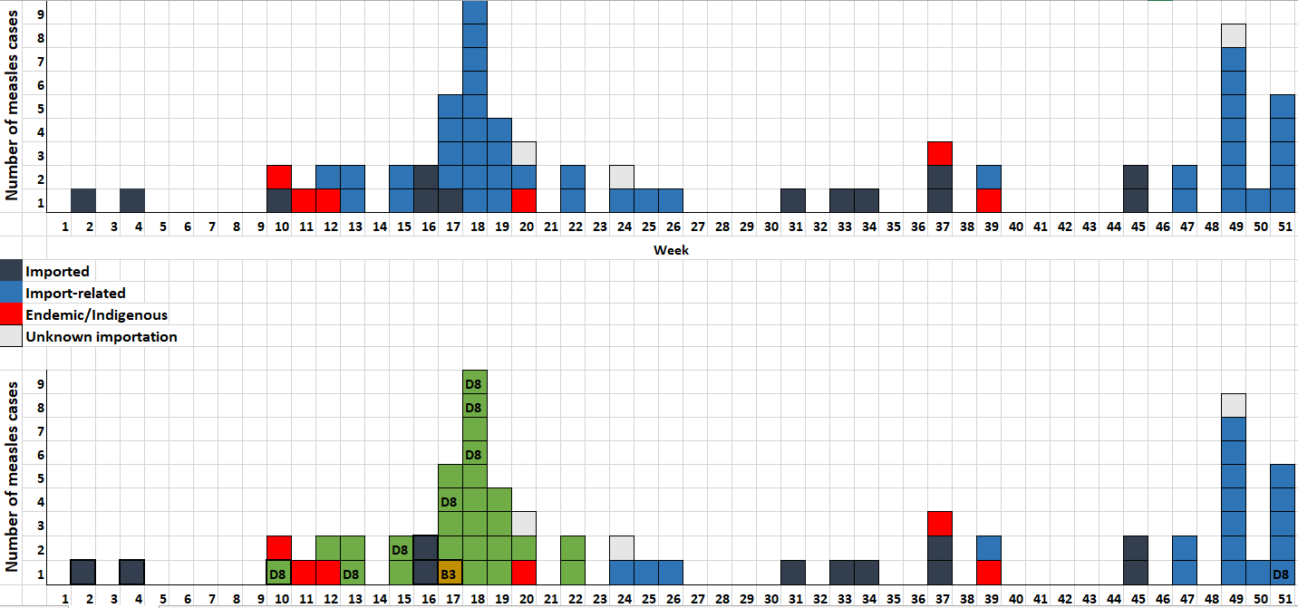

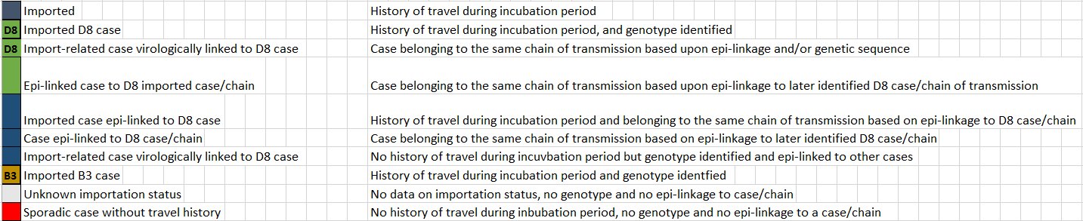

*Please refer to the Excel sheet provided at: http://www.emro.who.int/health-topics/measles/index.html?format=html#documentation-for-verification-of-elimination.

1. Measles cases by age cohort and vaccination status for the last 5 years:

**2019**

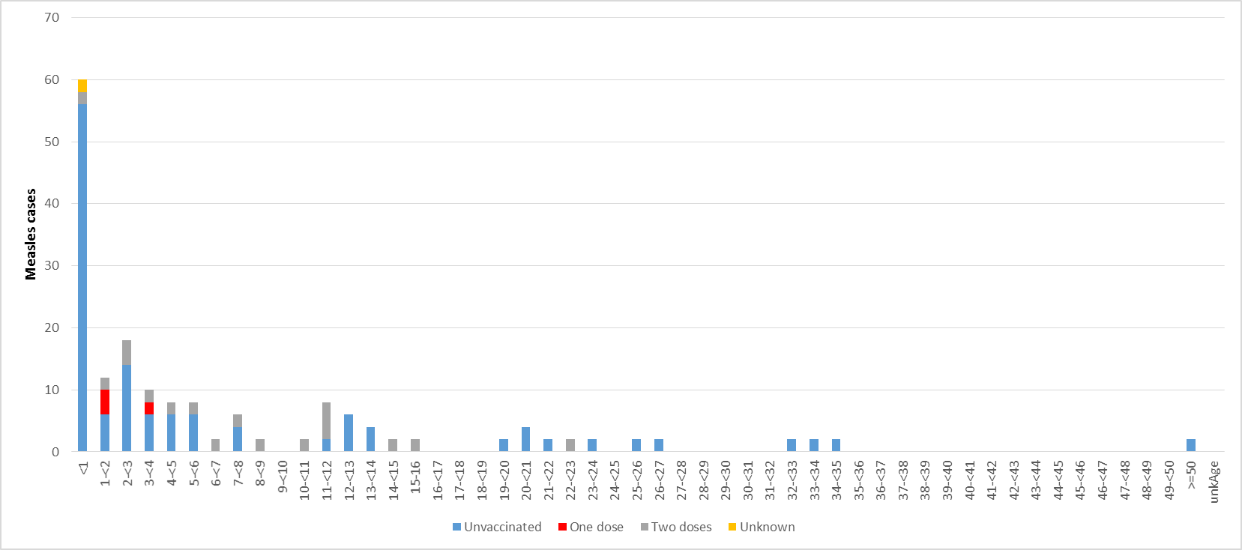

**2018**

**

**2017**

**

**2016**

**

**2015**

**

1. Analysis describing the epidemiology of measles*

*Please refer to the Excel sheet provided at: http://www.emro.who.int/health-topics/measles/index.html?format=html#documentation-for-verification-of-elimination.

1. Review of any special cases in the past 5 years:

* *Vaccine-associated:*
* *Equivocal:*
* *Clinically compatible (in elimination phase):*

1. Measles outbreaks in the last 5 years: *

| **Outbreak year\*** | **Governorate/district** | **Date of onset of the first case** | **Epi week of onset of first case** | **Date of onset of the last case or “ongoing”** | **Epi Week of onset of the last case** | **Total number of cases** | **Genotype/ Distinct sequence ID** | **MeaNS sample ID** | **WHO name** | **First case origin (source)** | **Comments** |
| --- | --- | --- | --- | --- | --- | --- | --- | --- | --- | --- | --- |
|  |  |  |  |  |  |  |  |  |  |  |  |
|  |  |  |  |  |  |  |  |  |  |  |  |
|  |  |  |  |  |  |  |  |  |  |  |  |
|  |  |  |  |  |  |  |  |  |  |  |  |
|  |  |  |  |  |  |  |  |  |  |  |  |

*\*Please include each outbreak, even in the same year, in a separate line.*

**Description of each outbreak:** *(include the identified immunity gap and measures taken to address this gap to prevent future outbreaks; maps of cases or epidemic curves may be included.)*

Please attach all detailed outbreak investigation reports as annex.

Please fill out the measles outbreak summary table in the Excel sheet provided at: http://www.emro.who.int/health-topics/measles/index.html?format=html#documentation-for-verification-of-elimination.

1. **Rubella and CRS**
2. Rubella cases, incidence and genotype at the national level since the introduction of the RCV:*

|  |  |  |  |  |  |  |  |  |  |  |  |
| --- | --- | --- | --- | --- | --- | --- | --- | --- | --- | --- | --- |
| **Rubella** |  |  |  |  |  |  |  |  |  |  |  |
| **Total suspected cases** |  |  |  |  |  |  |  |  |  |  |  |
| **Total confirmed cases** |  |  |  |  |  |  |  |  |  |  |  |
| **Total discarded** |  |  |  |  |  |  |  |  |  |  |  |
| **Pending classification** |  |  |  |  |  |  |  |  |  |  |  |
| **Total deaths related to rubella/CRS** |  |  |  |  |  |  |  |  |  |  |  |
| **Total incidence of cases** |  |  |  |  |  |  |  |  |  |  |  |
| **Incidence of indigenous cases** |  |  |  |  |  |  |  |  |  |  |  |
| **Genotype(s)** |  |  |  |  |  |  |  |  |  |  |  |
| **Clinical CRS cases** |  |  |  |  |  |  |  |  |  |  |  |
| **Confirmed CRS cases** |  |  |  |  |  |  |  |  |  |  |  |

*\*Please add columns as needed*.

1. Rubella cases and incidence at subnational level (province and districts as applicable):

**2019**

|  |  |  |  |  |  |  |  |  |  |  |  |  |  |  |  |  |
| --- | --- | --- | --- | --- | --- | --- | --- | --- | --- | --- | --- | --- | --- | --- | --- | --- |
| **Province** | **District** | **Population size** | **Jan** | **Feb** | **Mar** | **Apr** | **May** | **Jun** | **Jul** | **Aug** | **Sep** | **Oct** | **Nov** | **Dec** | **Total** | **Incidence rate** |
|  |  |  |  |  |  |  |  |  |  |  |  |  |  |  |  |  |
|  |  |  |  |  |  |  |  |  |  |  |  |  |  |  |  |  |
|  |  |  |  |  |  |  |  |  |  |  |  |  |  |  |  |  |
|  |  |  |  |  |  |  |  |  |  |  |  |  |  |  |  |  |
|  |  |  |  |  |  |  |  |  |  |  |  |  |  |  |  |  |
|  |  |  |  |  |  |  |  |  |  |  |  |  |  |  |  |  |
|  |  |  |  |  |  |  |  |  |  |  |  |  |  |  |  |  |

**2018**

|  |  |  |  |  |  |  |  |  |  |  |  |  |  |  |  |  |
| --- | --- | --- | --- | --- | --- | --- | --- | --- | --- | --- | --- | --- | --- | --- | --- | --- |
| **Province** | **District** | **Population size** | **Jan** | **Feb** | **Mar** | **Apr** | **May** | **Jun** | **Jul** | **Aug** | **Sep** | **Oct** | **Nov** | **Dec** | **Total** | **Incidence rate** |
|  |  |  |  |  |  |  |  |  |  |  |  |  |  |  |  |  |
|  |  |  |  |  |  |  |  |  |  |  |  |  |  |  |  |  |
|  |  |  |  |  |  |  |  |  |  |  |  |  |  |  |  |  |
|  |  |  |  |  |  |  |  |  |  |  |  |  |  |  |  |  |
|  |  |  |  |  |  |  |  |  |  |  |  |  |  |  |  |  |
|  |  |  |  |  |  |  |  |  |  |  |  |  |  |  |  |  |
|  |  |  |  |  |  |  |  |  |  |  |  |  |  |  |  |  |

**2017**

|  |  |  |  |  |  |  |  |  |  |  |  |  |  |  |  |  |
| --- | --- | --- | --- | --- | --- | --- | --- | --- | --- | --- | --- | --- | --- | --- | --- | --- |
| **Province** | **District** | **Population size** | **Jan** | **Feb** | **Mar** | **Apr** | **May** | **Jun** | **Jul** | **Aug** | **Sep** | **Oct** | **Nov** | **Dec** | **Total** | **Incidence rate** |
|  |  |  |  |  |  |  |  |  |  |  |  |  |  |  |  |  |
|  |  |  |  |  |  |  |  |  |  |  |  |  |  |  |  |  |
|  |  |  |  |  |  |  |  |  |  |  |  |  |  |  |  |  |
|  |  |  |  |  |  |  |  |  |  |  |  |  |  |  |  |  |
|  |  |  |  |  |  |  |  |  |  |  |  |  |  |  |  |  |
|  |  |  |  |  |  |  |  |  |  |  |  |  |  |  |  |  |
|  |  |  |  |  |  |  |  |  |  |  |  |  |  |  |  |  |
|  |  |  |  |  |  |  |  |  |  |  |  |  |  |  |  |  |

**2016**

|  |  |  |  |  |  |  |  |  |  |  |  |  |  |  |  |  |
| --- | --- | --- | --- | --- | --- | --- | --- | --- | --- | --- | --- | --- | --- | --- | --- | --- |
| **Province** | **District** | **Population size** | **Jan** | **Feb** | **Mar** | **Apr** | **May** | **Jun** | **Jul** | **Aug** | **Sep** | **Oct** | **Nov** | **Dec** | **Total** | **Incidence rate** |
|  |  |  |  |  |  |  |  |  |  |  |  |  |  |  |  |  |
|  |  |  |  |  |  |  |  |  |  |  |  |  |  |  |  |  |
|  |  |  |  |  |  |  |  |  |  |  |  |  |  |  |  |  |
|  |  |  |  |  |  |  |  |  |  |  |  |  |  |  |  |  |
|  |  |  |  |  |  |  |  |  |  |  |  |  |  |  |  |  |
|  |  |  |  |  |  |  |  |  |  |  |  |  |  |  |  |  |
|  |  |  |  |  |  |  |  |  |  |  |  |  |  |  |  |  |
|  |  |  |  |  |  |  |  |  |  |  |  |  |  |  |  |  |
|  |  |  |  |  |  |  |  |  |  |  |  |  |  |  |  |  |
|  |  |  |  |  |  |  |  |  |  |  |  |  |  |  |  |  |

**2015**

|  |  |  |  |  |  |  |  |  |  |  |  |  |  |  |  |  |
| --- | --- | --- | --- | --- | --- | --- | --- | --- | --- | --- | --- | --- | --- | --- | --- | --- |
| **Province** | **District** | **Population size** | **Jan** | **Feb** | **Mar** | **Apr** | **May** | **Jun** | **Jul** | **Aug** | **Sep** | **Oct** | **Nov** | **Dec** | **Total** | **Incidence rate** |
|  |  |  |  |  |  |  |  |  |  |  |  |  |  |  |  |  |
|  |  |  |  |  |  |  |  |  |  |  |  |  |  |  |  |  |
|  |  |  |  |  |  |  |  |  |  |  |  |  |  |  |  |  |
|  |  |  |  |  |  |  |  |  |  |  |  |  |  |  |  |  |
|  |  |  |  |  |  |  |  |  |  |  |  |  |  |  |  |  |
|  |  |  |  |  |  |  |  |  |  |  |  |  |  |  |  |  |
|  |  |  |  |  |  |  |  |  |  |  |  |  |  |  |  |  |
|  |  |  |  |  |  |  |  |  |  |  |  |  |  |  |  |  |
|  |  |  |  |  |  |  |  |  |  |  |  |  |  |  |  |  |
|  |  |  |  |  |  |  |  |  |  |  |  |  |  |  |  |  |

Spot maps to present geographical distribution of total rubella cases by province/district for the last 5 years:

Colour code for spot map:

* Green : Sporadic “imported” cases (unrelated to any other case in the country)
* Yellow : Case is part of an outbreak (>1 case)
* Red : Sporadic “unknown” case (unrelated to any other case in the country

Spot maps to present geographical distribution of discarded measles cases by province/district for the last 5 years:

Colour code for spot map:

* Red: >2/100000
* Green: <2/1000000

1. Rubella cases by final classification and source of infection at national level for the last 5 years:

**2019**

|  |  |  |  |  |
| --- | --- | --- | --- | --- |
| **Confirmation**  **Source of infection** | **Laboratory-confirmed** | **Epidemiologically linked** | **Clinically compatible** | **Total** |
| **Endemic** |  |  |  |  |
| **Unknown** |  |  |  |  |
| **Imported** |  |  |  |  |
| **Import-related** |  |  |  |  |
| **Total** |  |  |  |  |

**2018**

|  |  |  |  |  |
| --- | --- | --- | --- | --- |
| **Confirmation**  **Source of infection** | **Laboratory-confirmed** | **Epidemiologically linked** | **Clinically compatible** | **Total** |
| **Endemic** |  |  |  |  |
| **Unknown** |  |  |  |  |
| **Imported** |  |  |  |  |
| **Import-related** |  |  |  |  |
| **Total** |  |  |  |  |

**2017**

|  |  |  |  |  |
| --- | --- | --- | --- | --- |
| **Confirmation**  **Source of infection** | **Laboratory-confirmed** | **Epidemiologically linked** | **Clinically compatible** | **Total** |
| **Endemic** |  |  |  |  |
| **Unknown** |  |  |  |  |
| **Imported** |  |  |  |  |
| **Import-related** |  |  |  |  |
| **Total** |  |  |  |  |

**2016**

|  |  |  |  |  |
| --- | --- | --- | --- | --- |
| **Confirmation**  **Source of infection** | **Laboratory-confirmed** | **Epidemiologically linked** | **Clinically compatible** | **Total** |
| **Endemic** |  |  |  |  |
| **Unknown** |  |  |  |  |
| **Imported** |  |  |  |  |
| **Import-related** |  |  |  |  |
| **Total** |  |  |  |  |

**2015**

|  |  |  |  |  |
| --- | --- | --- | --- | --- |
| **Confirmation**  **Source of infection** | **Laboratory-confirmed** | **Epidemiologically linked** | **Clinically compatible** | **Total** |
| **Endemic** |  |  |  |  |
| **Unknown** |  |  |  |  |
| **Imported** |  |  |  |  |
| **Import-related** |  |  |  |  |
| **Total** |  |  |  |  |

d) CRS cases by final classification at national level for the last 5 years:

**2019**

|  |  |  |  |  |
| --- | --- | --- | --- | --- |
| **Confirmation**  **Source of infection** | **Laboratory-confirmed** | **Epidemiologically linked** | **Clinically compatible** | **Total** |
| **Endemic** |  |  |  |  |
| **Unknown** |  |  |  |  |
| **Imported** |  |  |  |  |
| **Import-related** |  |  |  |  |
| **Total** |  |  |  |  |

**2018**

|  |  |  |  |  |
| --- | --- | --- | --- | --- |
| **Confirmation**  **Source of infection** | **Laboratory-confirmed** | **Epidemiologically linked** | **Clinically compatible** | **Total** |
| **Endemic** |  |  |  |  |
| **Unknown** |  |  |  |  |
| **Imported** |  |  |  |  |
| **Import-related** |  |  |  |  |
| **Total** |  |  |  |  |

**2017**

|  |  |  |  |  |
| --- | --- | --- | --- | --- |
| **Confirmation**  **Source of infection** | **Laboratory-confirmed** | **Epidemiologically linked** | **Clinically compatible** | **Total** |
| **Endemic** |  |  |  |  |
| **Unknown** |  |  |  |  |
| **Imported** |  |  |  |  |
| **Import-related** |  |  |  |  |
| **Total** |  |  |  |  |

**2016**

|  |  |  |  |  |
| --- | --- | --- | --- | --- |
| **Confirmation**  **Source of infection** | **Laboratory-confirmed** | **Epidemiologically linked** | **Clinically compatible** | **Total** |
| **Endemic** |  |  |  |  |
| **Unknown** |  |  |  |  |
| **Imported** |  |  |  |  |
| **Import-related** |  |  |  |  |
| **Total** |  |  |  |  |

**2015**

|  |  |  |  |  |
| --- | --- | --- | --- | --- |
| **Confirmation**  **Source of infection** | **Laboratory-confirmed** | **Epidemiologically linked** | **Clinically compatible** | **Total** |
| **Endemic** |  |  |  |  |
| **Unknown** |  |  |  |  |
| **Imported** |  |  |  |  |
| **Import-related** |  |  |  |  |
| **Total** |  |  |  |  |

e) Rubella epidemic curve for the last 10 years:

* *Rubella monthly epidemic curve for the last 10 years:*
* *Rubella weekly epidemic curve by source of infection and genotype\**

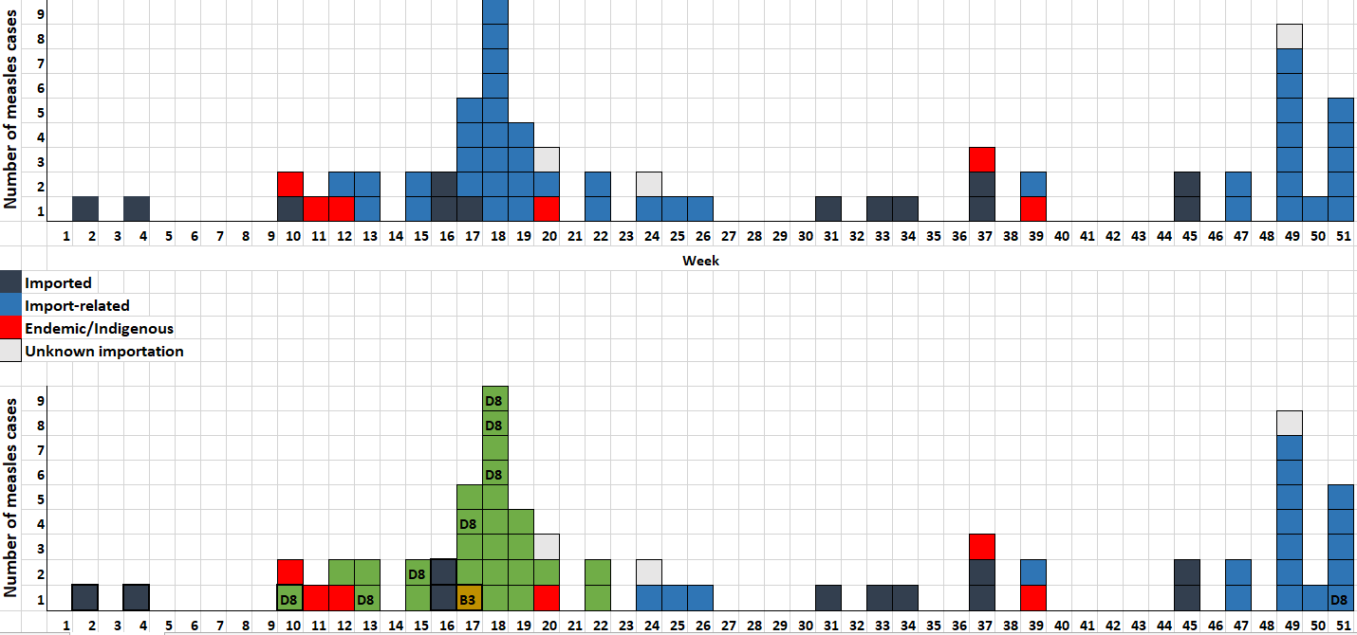

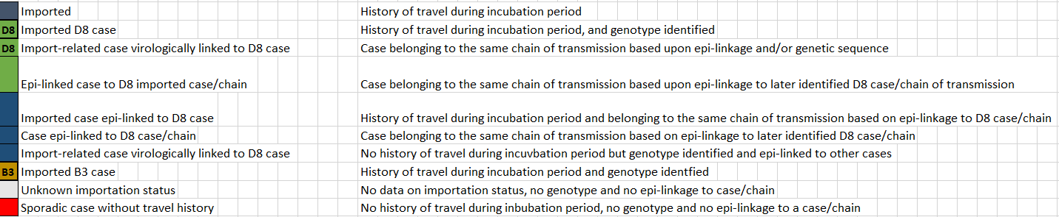

*Please refer to the Excel sheet provided at: http://www.emro.who.int/health-topics/measles/index.html?format=html#documentation-for-verification-of-elimination.

f) Rubella cases by age cohort and vaccination status for the last 5 years:

**2019**

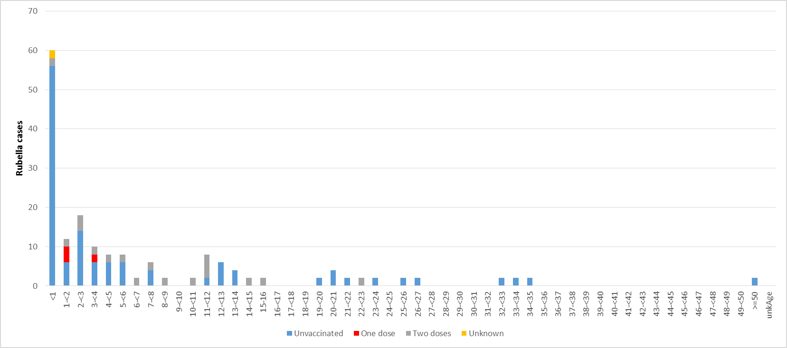

**2018**

**

**2017**

**

**2016**

**

**2015**

**

g) Analysis describing the epidemiology of rubella:*

*Please refer to the Excel sheet provided at: http://www.emro.who.int/health-topics/measles/index.html?format=html#documentation-for-verification-of-elimination.

h) Review of any special cases in the past 5 years:

* *Vaccine-associated:*
* *Equivocal:*
* *Clinically compatible (in elimination phase):*

I) Rubella outbreaks in the last 5 years:*

| **Outbreak year\*** | **Governorates/districts** | **Date of onset of the first case** | **Epi week of onset of first case** | **Date of onset of the last case or “ongoing”** | **Epi week of onset of last case** | **Total number of cases** | **Genotype/distinct sequence ID** | **RubeNS sample ID** | **WHO name** | **First case origin (source)** | **Comments** |
| --- | --- | --- | --- | --- | --- | --- | --- | --- | --- | --- | --- |
|  |  |  |  |  |  |  |  |  |  |  |  |
|  |  |  |  |  |  |  |  |  |  |  |  |
|  |  |  |  |  |  |  |  |  |  |  |  |
|  |  |  |  |  |  |  |  |  |  |  |  |
|  |  |  |  |  |  |  |  |  |  |  |  |

*\*Please include each outbreak, even in the same year, in a separate line.*

**Description of each outbreak** *(include the identified immunity gap and measures taken to address this gap to prevent future outbreaks; maps of cases or epidemic curves may be included).*

*Please attach all detailed outbreak investigation reports as annex.*

1. 1. **Second line of evidence: molecular epidemiology evidence that measles and/or rubella virus transmission is interrupted**

*This section describes the molecular epidemiology evidence of the interruption of transmission, noting the genotypes over time. Data should include all data collected since genotyping became available. The narrative should highlight the collection of specimens as well as what the genotypic data is currently showing.*

***Instructions:*** *Please provide the following information:*

*Genotype, name strain or sequence variant and number of measles and rubella virus strains identified by year and month, for all years since genotyping became available, with a focus on the most recent 5 years in support of achieving measles and rubella elimination.*

* *Other information such as sequencing information of cases by date of onset, location and importation history and phylogenetic tree should be included, when available.*
* *Sequence name of matches in the MeaNS or RubeNS database, using the exact match strain, or, if available, the named strains for measles and rubella.*
* *For measles only, the detection of variant lineages within a genotype should be described if available, and the sequence differences presented as a phylogenetic tree or distance table. Sequence variants should be linked to closely related sequences in MeaNS.*
* *National reference laboratories should report all genomic sequence data to the global online databases:*
* *MeaNS: WHO Measles Nucleotide Surveillance online database (*[*http://www.who-measles.org*](http://www.who-measles.org)*)*
* *RubeNS: WHO Rubella Nucleotide Surveillance online database (*[*http://www.who-rubella.org*](http://www.who-rubella.org)*)*
* *An epi-curve including genetic sequence data (can refer to the previous curve).*
  + - * 1. Genotypic information of measles/rubella cases for the past 5 years

1. Measles

|  |  |  |  |  |  |  |  |  |  |  |  |  |  |  |
| --- | --- | --- | --- | --- | --- | --- | --- | --- | --- | --- | --- | --- | --- | --- |
| **Year** | **Case ID** | **MeaNS ID** | **WHO name** | **First admin Level** | **Country** | **City** | **Sample date** | **Date of onset of rash** | **Recent travel** | **First case origin (source)** | **Geno-type** | **Distinct Seq ID** | **Named strain** | **Tested in WHO-accredited laboratory? (Yes/No**) |
|  |  |  |  |  |  |  |  |  |  |  |  |  |  |  |
|  |  |  |  |  |  |  |  |  |  |  |  |  |  |  |
|  |  |  |  |  |  |  |  |  |  |  |  |  |  |  |
|  |  |  |  |  |  |  |  |  |  |  |  |  |  |  |
|  |  |  |  |  |  |  |  |  |  |  |  |  |  |  |
|  |  |  |  |  |  |  |  |  |  |  |  |  |  |  |

1. Rubella

|  |  |  |  |  |  |  |  |  |  |  |  |  |  |  |
| --- | --- | --- | --- | --- | --- | --- | --- | --- | --- | --- | --- | --- | --- | --- |
| **Year** | **Case ID** | **RubeNS ID** | **WHO name** | **First admin Level** | **Country** | **City** | **Sample date** | **Date of onset of rash** | **Recent travel** | **First case origin (source)** | **Geno-type** | **Distinct Seq ID** | **Named strain** | **Tested in WHO-accredited laboratory? (Yes/No)** |
|  |  |  |  |  |  |  |  |  |  |  |  |  |  |  |
|  |  |  |  |  |  |  |  |  |  |  |  |  |  |  |
|  |  |  |  |  |  |  |  |  |  |  |  |  |  |  |
|  |  |  |  |  |  |  |  |  |  |  |  |  |  |  |
|  |  |  |  |  |  |  |  |  |  |  |  |  |  |  |
|  |  |  |  |  |  |  |  |  |  |  |  |  |  |  |

* + - * 1. Phylogenetic tree or identified transmission chains and sporadic cases:
        2. Include genetic sequencing data into epi-curves (can refer to previous epi-curves):

* 1. **Third line of evidence: measles and rubella surveillance system quality**

***Instructions:*** *Please provide the following information:*

* *Detailed description of the design and extent of case-based surveillance for measles and rubella, in terms of case definition, specific population covered, representativeness, and sources of case reporting.*
* *Epidemiological and laboratory standard surveillance performance indicators for measles and rubella (see Annex 2 of Guide to the documentation and verification of measles and rubella elimination in the WHO Eastern Mediterranean Region).*
* *Analysis against the standard surveillance system performance indicators,*[2] *conducted at the second administrative level (state/province/governorate) or third administrative level (for example, district, locality) in big countries and focusing on areas with poor performance illustrated in map/table for the past 5 years and action taken to address it.*
* *Description and results of active case search conducted in silent or high-risk areas.*
* *Documentation of special surveys, epidemiological and other research studies conducted.*
* *Detailed description of the characteristics of clinically compatible measles and clinically compatible rubella cases. When countries are approaching elimination and measles and rubella surveillance performs well, that is, adequate case investigations with contact tracing are routinely performed and adequate specimens routinely collected, the number of clinically compatible measles and rubella cases should be small. The following should be described for compatible cases:* 
  + *map to show clustering, if present*
  + *age and immunization status*
  + *clinical signs and symptoms consistent with measles or rubella (yes or no)*
  + *cases discarded by the Expert Review Committee.*
* *A detailed description of the CRS surveillance system, including how cases are identified, confirmed and reported.*
* *Periodic retrospective searches for suspected CRS cases conducted when the standard surveillance system does not detect many suspect cases.*
* *Description illustrated in a table for the number of measles/rubella cases tested either through serology or molecular testing in the period 2015–2019.*
* *If there are surveillance and laboratory gaps, the report should include information on actions taken to identify and address them.*
* *Other supportive data, for example:*
  + *Surveillance activities or a survey may be added to provide further evidence on surveillance quality and can be illustrated in figure or narrative description.*
  + *Description of alternative indicators or methods used or available to evaluate surveillance performance (if any), and demonstrate high-quality surveillance, either to support a strong surveillance system, or explain how surveillance data can support the conclusions of the NVC.*
  + *Attach any reports of measles/rubella surveillance system review.*
* *Description of the relationship between NIP, measles/rubella surveillance team and laboratory department: communication, coordination, information sharing, meetings, and so on.*

1. Surveillance system description
2. Case definition:

* Measles surveillance case definition:
* Rubella surveillance case definition:

1. Populations reached by surveillance:
2. Representativeness of surveillance/involvement of non-MOH health care providers:
3. Source of case reporting:

e) Laboratory testing algorithm for case confirmation:

f) Laboratory procedures capacity

Measles Rubella

□ Serology □ Serology

□ Detection RT-PCR □ Detection RT-PCR

□ Genotyping RT-qPCR □ Genotyping RT-qPCR

□ Sequencing □ Sequencing

□ Cell Culture □ Cell Culture

g) Laboratory proficiency

The three previous accreditations of measles/rubella laboratory:

|  |  |
| --- | --- |
| Year | Accreditation status |
|  |  |
|  |  |
|  |  |



1. Analysis of standard surveillance system performance indicators:
2. Measles/rubella surveillance system indicators:

| **Measles/rubella** | **Target** | **2015** | **2016** | **2017** | **2018** | **2019** |
| --- | --- | --- | --- | --- | --- | --- |
| **Epidemiological/case report** |  |  |  |  |  |  |
| **Proportion of surveillance units reporting measles and rubella data to the national level (completeness); large countries should report on third administrative level as well** | ≥80% |  |  |  |  |  |
| **Proportion of surveillance units reporting measles and rubella data to the national level on time (timeliness)** | ≥80% |  |  |  |  |  |
| **Reporting rate of discarded non-measles non-rubella cases at national level** | ≥2 /100 000 |  |  |  |  |  |
| **Proportion of second administrative level units (province, governorate etc.) reporting at least two discarded non-measles non-rubella case per 100 000 population**  **(Reporting on third administrative level in large countries)** | ≥80% |  |  |  |  |  |
| **Proportion of suspected measles and rubella cases with adequate investigation initiated within 48 hours of notification** | ≥80% |  |  |  |  |  |
| **Proportion of specimens received at the laboratory within 5 days of collection** | ≥80% |  |  |  |  |  |
| **Laboratory** |  |  |  |  |  |  |
| **Proportion of suspected cases with adequate specimen collection for detecting acute measles and rubella infection collected and tested in a proficient laboratory** | ≥80% |  |  |  |  |  |
| **Proportion of laboratory-confirmed chains of transmission (defined as one or more confirmed measles cases) with specimens adequate for detecting measles virus collected and tested in an accredited laboratory** | ≥80% |  |  |  |  |  |
| **Proportion of serology results reported to national public health authorities by the laboratory within 4 days of specimen receipt** | ≥80% |  |  |  |  |  |

1. CRS surveillance indicators:

|  |  |  |  |  |  |  |
| --- | --- | --- | --- | --- | --- | --- |
| **CRS** | **Target** | **2015** | **2016** | **2017** | **2018** | **2019** |
| **Annual rate of suspected CRS cases at the national level** | ≥ 1 per 10 000 live births |  |  |  |  |  |
| **Proportion of suspected CRS cases with the key data points completed[3]** | ≥80% |  |  |  |  |  |
| **Proportion of suspected cases with adequate blood specimen tested for laboratory confirmation (IgM/IgG, PCR) in an accredited laboratory** | ≥80% |  |  |  |  |  |
| **Proportion of confirmed cases with adequate specimen tested for virus detection** | ≥80% |  |  |  |  |  |
| **Proportion of confirmed cases with at least two negative tests for virus detection/isolation after 3 months of age, with at least a 1-month interval between tests** | ≥80% |  |  |  |  |  |
| **Proportion of confirmed CRS cases detected within 3 months of birth** | ≥80% |  |  |  |  |  |
| **Proportion of specimens (serologic or virologic) received at the laboratory within 5 days of collection** | ≥80% |  |  |  |  |  |
| **Proportion of serologic results reported by the laboratory within 4 days of receiving the specimen** | ≥80% |  |  |  |  |  |

1. Map/table of key surveillance indicators at the subnational level for the past 5 years (district if possible):
2. Description of action taken to address poor performance indicators for the past 5 years:
3. Description and results of active search conducted in silent areas:
4. A detailed description of the CRS surveillance system, including how cases are identified, confirmed and reported:
5. Detailed description of periodic retrospective searches for suspected CRS cases:
6. Other supportive data:
7. Description of any other surveillance activities, surveys or reviews (full reports should be attached if available):
8. Description of any other alternative indicators used by the country to support a high-quality surveillance system:
9. Laboratory testing and molecular epidemiology of measles and rubella viruses in 2015–2019:

|  |  |  |  |  |  |  |  |  |  |  |  |  |  |  |  |  |
| --- | --- | --- | --- | --- | --- | --- | --- | --- | --- | --- | --- | --- | --- | --- | --- | --- |
| **Year** | **Number of suspected cases** | **Serology** | | | | | | | **Virus detection and genotyping** | | | | | | | **WHO-accredited laboratory** |
| **Number of samples collected *(blood, oral fluid, DBS)** | **Number received at laboratory** | **Number tested** | **Positive** | **Negative** | **Equivocal** | **Results ≤ 4 days %** | **Number of viral samples collected** | **Measles virus isolation *(swab, urine)** | | **Measles RT PCR *(swab, oral fluid)** | | **Geno-type detected** | **Results ≤ 2 month %** |  |
| **Number**  **tested** | **Number of isolates** | **Number tested** | **Positive** |
| **2015** |  |  |  |  |  |  |  |  |  |  |  |  |  |  |  |  |
| **2016** |  |  |  |  |  |  |  |  |  |  |  |  |  |  |  |  |
| **2017** |  |  |  |  |  |  |  |  |  |  |  |  |  |  |  |  |
| **2018** |  |  |  |  |  |  |  |  |  |  |  |  |  |  |  |  |
| **2019** |  |  |  |  |  |  |  |  |  |  |  |  |  |  |  |  |

1. NIP/Surveillance team/laboratory networking or relationship:
   1. **Fourth line of evidence: population immunity**

***Instructions:*** *Please provide the following information:*

* *Description of the source, denominator used and methodologies for calculating target population, vaccinated population and vaccination coverage by each level (health centre, district, province and country).*
* *Description of trends of routine MCV and RCV coverage over time from various data sources illustrated in table.*
* *A graph (or graphs) showing national MCV and RCV coverage, measles and rubella cases, and timing of SIAs over a period of time. (The graph should show trends over a number of years, for example, 10 years, if available.)*
* *A graph (or graphs) showing number and percentage vaccinated with MCV1, MCV2, MCV-SIA and RCV and RCV-SIA by the year of birth, and by sex if previous vaccination policies were sex-specific.*
* *Maps showing district MCV1, RCV1, MCV2, and RCV2 coverage over a number of years for which the data are available. Graph showing the same, but for age group instead of district.*
* *Consideration/evaluation of quality of vaccination coverage at each level and the representativeness of the reported vaccination coverage to population immunity by level, such as data quality assessment reports.*
* *Review of vaccination coverage in specific groups that may have higher levels of susceptibility, such as migrants, and nomadic populations.*
* *Detailed information on immunization coverage/status of domestic and international migrants.*
* *A summary of SIAs, including target population, target age group, geographic areas (national or subnational), implementation dates and implementation status (number of people immunized, reported coverage) presented in a table or graph.*
* *If available, the number of children without vaccination history who were vaccinated in each MCV-SIA.*
* *Results of coverage surveys conducted to assess routine or supplemental immunization, including sero-surveys to assess population immunity.*
* *If available, results of coverage surveys, sero-surveys and registries to assess RCV coverage, especially among women of reproductive age.*
* *Vaccination activities for protecting adolescents and adults against measles and rubella infection, for example the proportion/number of adolescents and adults vaccinated with measles- and rubella-containing vaccines by year of birth over a number of years for which the data are available.*
* *Modelling of the accumulation of measles- and rubella-susceptible individuals, if available.*
* *Assessment or consideration of the risk of large-scale outbreaks following importation, which may include assessment of the infrastructure for maintaining vaccine potency as well as an analysis of any gaps that may have compromised population immunity.*

1. Routine immunization coverage:
2. Description of the source of target population figures (denominator) and any concern related to the quality of these figures:
3. Description of the calculation of target population, number vaccinated:
4. Target population and vaccination coverage by each level for the previous 10 years:
5. Routine MCV and RCV coverage over time from various data sources since the introduction of the vaccine:

|  |  |  |  |  |  |  |  |  |  |  |
| --- | --- | --- | --- | --- | --- | --- | --- | --- | --- | --- |
| **Variable\*** | **Year** | | | | | | | | | |
|  |  |  |  |  |  |  |  |  |  |
| **Admin national MCV1 coverage** |  |  |  |  |  |  |  |  |  |  |
| **Admin national MCV2 coverage** |  |  |  |  |  |  |  |  |  |  |
| **WHO-UNICEF estimates of MCV1 coverage** |  |  |  |  |  |  |  |  |  |  |
| **WHO-UNICEF estimates of MCV2 coverage** |  |  |  |  |  |  |  |  |  |  |
| **% districts with ≥95% coverage of MRCV1**[4] |  |  |  |  |  |  |  |  |  |  |
| **% districts with ≥95% coverage of MRCV2**16 |  |  |  |  |  |  |  |  |  |  |

*\**Information available at : <http://apps.who.int/immunization_monitoring/globalsummary>.

1. Cohort analysis of routine coverage by males and females since the introduction of the vaccine, as applicable:
2. Cohort analysis of routine coverage since the introduction of the vaccine, as applicable on the subnational level (province/district):
3. Description of areas with low vaccination coverage

* Identify all areas at the first subnational administrative level where the coverage with first and/or second doses was less than 95% (by district if available):
* Identify high-risk populations based upon vaccination coverage (for example, ethnic sub-groups, wealthy families):
* Actions taken in recent years to improve routine immunization coverage in poor performing areas and the outcome:

1. Results of any coverage surveys, serosurveys or data quality assessments performed (please attach the reports):
2. If available, results of coverage surveys, serosurveys and registries to assess RCV coverage, especially among women at reproductive age:
3. Supplemental immunization activities (SIAs):
4. Data regarding all MCV and/or RCV SIAs:

|  |  |  |  |  |  |  |  |  |  |
| --- | --- | --- | --- | --- | --- | --- | --- | --- | --- |
| **Year of SIA conducted as national or subnational** | **Vaccine (M, MR, MMR)** | **Dates**  **(start-end)** | **Age (range) of target group** | **Target population size** | **Coverage *(add columns to include admin and survey coverage in separate columns)*** | | | | |
| **National admin coverage (%)** | **National survey coverage (%)** | **% districts with coverage <90%**  ***(specify admin or survey results)*** | **% districts with coverage 90–94%**  ***(specify admin or survey results)*** | **% districts with coverage ≥ 95%**  ***(specify admin or survey results)*** |
|  |  |  |  |  |  |  |  |  |  |
|  |  |  |  |  |  |  |  |  |  |
|  |  |  |  |  |  |  |  |  |  |
|  |  |  |  |  |  |  |  |  |  |
|  |  |  |  |  |  |  |  |  |  |
|  |  |  |  |  |  |  |  |  |  |
|  |  |  |  |  |  |  |  |  |  |
|  |  |  |  |  |  |  |  |  |  |
|  |  |  |  |  |  |  |  |  |  |

1. Qualitative assessment of most recent SIA, including assessment of the heterogeneity of coverage:
2. Description of subnational SIAs, areas covered and coverage reached:
3. Maps of areas (governorates/districts) covered by SIAs in the last 5 years
4. Review of vaccination coverage in specific groups that may have higher levels of susceptibility, such as migrants, nomadic populations:
5. Detailed information on immunization coverage/status domestic and international migration:

* Immunization coverage among domestic migration:
* Immunization coverage among international migration:

1. Immunity gaps:
2. Results of coverage surveys conducted to assess routine or supplemental immunization, including serosurveys to assess population immunity *(please attach the full report)*:
3. Vaccination activities for protecting adolescents and adults against measles and rubella infection *(for example proportion/number of adolescents and adults vaccinated with measles- and rubella-containing vaccines by year of birth)*:
4. Cohort analysis of vaccination coverage in specific group:

* Vaccination activities among adolescents:
* Vaccination activities among adults:

1. Modelling of the accumulation of measles and rubella-susceptible individuals (if available):
2. Risk assessment on possibility of occurrence of large-scale outbreaks following importation:

* Assessment of the infrastructure for maintaining vaccine potency:
* Analysis of any gaps that may have compromised population immunity:

* 1. **Fifth line of evidence: sustainability of national immunization programme**

***Instructions:*** *Please provide the following information:*

* *Documents indicating the legal basis of the NIP and any other supporting documents demonstrating political commitment for the sustainability of elimination.*
* *Annual risk assessments at all levels.*
* *Developed action plan to address identified gaps in risk assessment.*
* *Comprehensive multi-year plan (cMYP), or similar, and an annual NIP plan of action where requirements of sustainability of elimination, the ability of government and partners to implement the plan, and sufficient funding are clearly reflected.*
* *A diagram illustrating NIP’s interaction with partners and other governmental entities with their role.*
* *Evidence of sustainability in funding and monetary resources for both the epidemiological and laboratory surveillance components.*
* *Supporting documents indicating the financial support to fund vaccine procurement and surveillance activities.*
* *Evidence of government and partner commitment to providing adequate human resources for measles/rubella elimination components (epidemiological surveillance, laboratory surveillance and immunization).*
* *An updated NIP strategic plan updated with proof of dissemination, especially plans to improve coverage in low coverage areas, populations and other known immunity gaps as well as to strengthen surveillance in poor performing areas.*
* *Outbreak preparedness and response plan with adequate resources for implementation and lessons learned from previous outbreaks, where appropriate.*
* *Availability of updated, approved and disseminated standard operating procedure.*
* *Details of other strategies/national policies that will contribute to accelerating/sustaining measles elimination and their implementation, for example reducing nosocomial infection and transmission.*
* *Review of causes for vaccine stock-out and the indicators of vaccine availability such as zero stock-outs of MCV and RCV at the peripheral level and 100% of funding for MCV and RCV, by government.*
* *Monitoring systems for measuring public acceptance of vaccination.*
* *Advocacy and communication for raising public awareness and monitoring system for public acceptance of vaccines.*

1. Political commitment:
2. Description of the political commitment for the sustainability of elimination *(please attach supporting documents indicating the legal basis of the NIP, political commitment to the sustainability of elimination, and financial support to fund vaccine procurement and surveillance)*:
3. Annual risk assessment at all levels *(please attach supporting documents)* and action taken to address any identified gaps:
4. Description of the cMYP and annual plan, and ability of government and partners to implement the plan, and achieve/maintain elimination:
5. Role of partners, (illustrate NIP’s interaction with partners and other governmental entities with diagram):
6. Description of advisory committees:

1. Sustainable human and financial resources:
2. Description of the government and partner commitment to providing adequate human and monetary resources for immunizations, including measles/rubella elimination:
3. Funding sources for NIP to procure vaccine, and its sustainability:
4. Review causes for vaccine stock-outs:

1. Programmatic commitment:

1. Presence of multi-year plan for measles elimination:
2. Presence of plan of action to address immunity gaps in coming years, and maintain high-level surveillance currently and after elimination:
3. Actions for outbreak investigation and response to identify and fill immunity gaps, including available resources to implement plan and responses:
4. Details of other strategies/national policies that will contribute to accelerating/sustaining measles elimination and their implementation, for example reducing nosocomial infection and transmission:
5. Indicators of vaccine availability such as zero stock-outs of MCV and RCV at the peripheral level and 100% of funding for MCV and RCV by government:
6. Monitoring systems for measuring public acceptance of vaccination:

Section 4. Verification, comments, conclusions and recommendations of the NVC

*Instructions: This section provides a summary of the NVC’s assessment of the status of the country towards achieving elimination for measles and/or rubella including the categorization. The section should summarize the findings for each of the five lines of evidence described above as part of the justification for the NVC’s conclusion regarding the status of elimination in the country (in addition to the executive summary submitted as a summary of the report).*

1. Description of the situation vis-à-vis the five lines of evidence:
2. Conclusion *(give a classification to the country as either endemic, re-established, near-elimination or elimination for both measles and rubella along with other conclusions)*:
3. Challenges facing achieving elimination:
4. Recommendations:

1. If there is no rubella elimination target for the country, the NVC should focus on measles elimination activities only, although some general information about the situation of rubella from the existing data sources in the country should also be provided.
2. WHO, Weekly Epidemiological Record, 2013; 9: 88, 89–100, http://www.who.int/wer/2013/wer8809.pdf?ua=; and WHO, Weekly Epidemiological Record, 2017: 9/10: 97–105, http://apps.who.int/iris/bitstream/handle/10665/254652/WER9209-10.pdf;jsessionid=EAD8BC95A3F502924D29D9B3A087779C?sequence=1 (accessed 6 December 2018).
3. Includes all key data points except travel history of mother. See Guide to the documentation and verification of measles and rubella elimination in the WHO Eastern Mediterranean Region page 25 for more details.
4. Service statistics/administrative data.